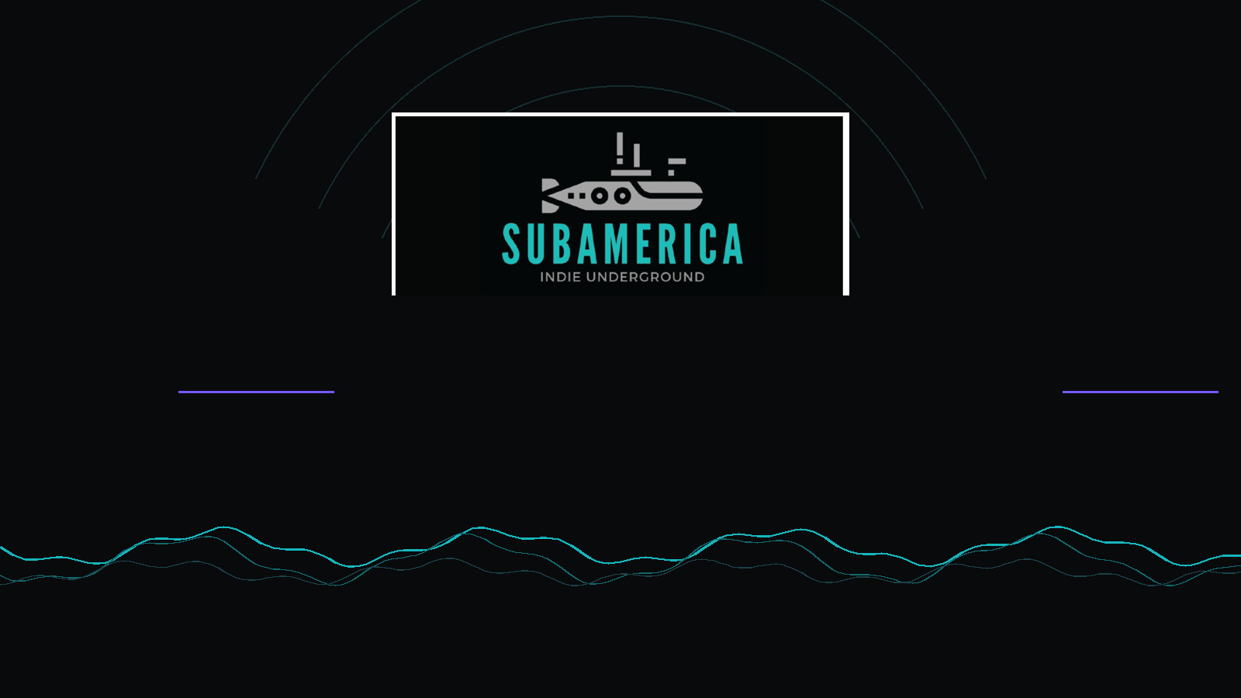
MUSE PLATFORMS
Subamerica Network
SEO + AEO + GEO Case Study
Expanding search visibility and AI discoverability for an indie underground creator and streaming network
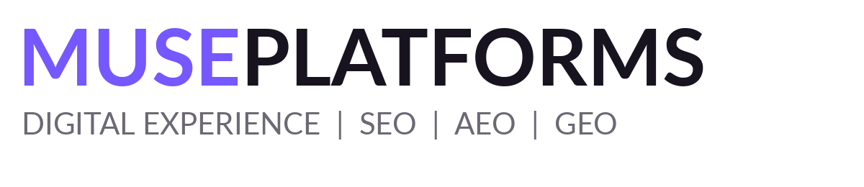 | 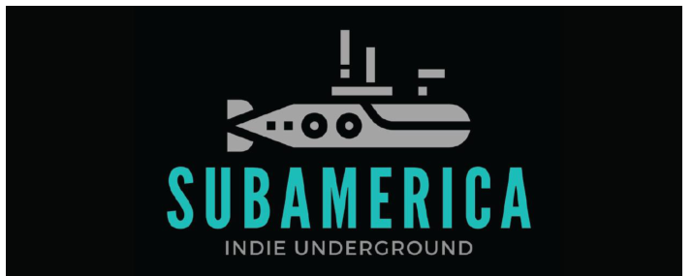
Source set supplied: 6 reports covering August and September 2026 | SEO, AEO and GEO

01 / EXECUTIVE SNAPSHOT
Search growth, AI readiness and model visibility
The supplied reports show a connected visibility program across traditional search, answer engines and generative AI systems.
Sep active users  3,142  SEO report snapshot | Sep new users  3,122  SEO report snapshot | Sep sessions  3,997  SEO report snapshot
Sep events  29,001  SEO report snapshot | AEO answer inclusion  100  September audit | AEO generative visibility  100  September audit
GEO share of voice  51%  September brand-visibility scan | GEO overall score  44  September brand-visibility scan | Sep page-1 keywords  5 / 10  NYC keyword set

The story in one line
Subamerica moved from a search program centered on branded and “underground platform” discovery into a broader system spanning creator, streaming, monetization and connected-TV queries, with AI answer and citation visibility becoming measurable alongside SEO rankings.

Traditional search  5 / 10  Five of ten listed NYC keywords were on page 1 in the 21-Sep SEO report, including Subamerica Creator Portal and Subamerica Network at #1.  The tracked set also expanded into “Indie Underground Media Network” and “Indie Underground Streaming TV,” both at #1. | AI discovery  51%  The 21-Sep GEO report records 51% share of voice across 169 AI-model responses from 42 tracked queries.  The same scan reports model hit rates of 91% Perplexity, 45% Gemini, 45% ChatGPT and 36% Claude.

Current site context: Subamerica describes itself as an indie underground network streaming art, sound and stories 24/7 from New York City, with distribution across Roku, Google TV, Fire TV and Apple TV.

02 / CONTEXT
The discovery challenge
Subamerica sits in a category where audiences may search for a brand, a creator tool, a broadcast outlet, a streaming destination or a monetization model - often using long, conversational questions.
What search needed to understand  A single semantic picture of Subamerica as an independent / indie underground media network, creator platform and streaming destination.  Clear relationships between creators, artists, streaming, broadcast, monetization, connected TV and community.  Answer-ready content for “how do I…”, “where can I…”, “what is…” and comparison questions. | What the reports surfaced  August AEO diagnostics flagged schema, FAQ, content-depth and entity-signaling gaps.  August GEO showed very strong Perplexity and ChatGPT hit rates, but no Claude hits in that test set.  September AEO showed fewer critical issues and stronger AI visibility signals; September GEO surfaced new question-level citation opportunities.

Engagement objectives
- Strengthen NYC search visibility for the Subamerica brand and creator-platform proposition.
- Improve machine readability through structured data, semantic page architecture and answer-style content.
- Increase the chance that AI systems cite or recommend Subamerica for creator, streaming and independent-media questions.
- Build a consistent entity footprint across the website and external surfaces.
Why the mix matters
Muse positions AEO and generative AI search optimization as an emerging practice designed for changing discovery behavior. For Subamerica, that means optimizing not just for rank, but for understanding, answerability and citation.

03 / SEO PERFORMANCE
A larger organic footprint with deeper engagement signals
The two SEO reports provide clear before/after snapshots for analytics volume and NYC keyword coverage.
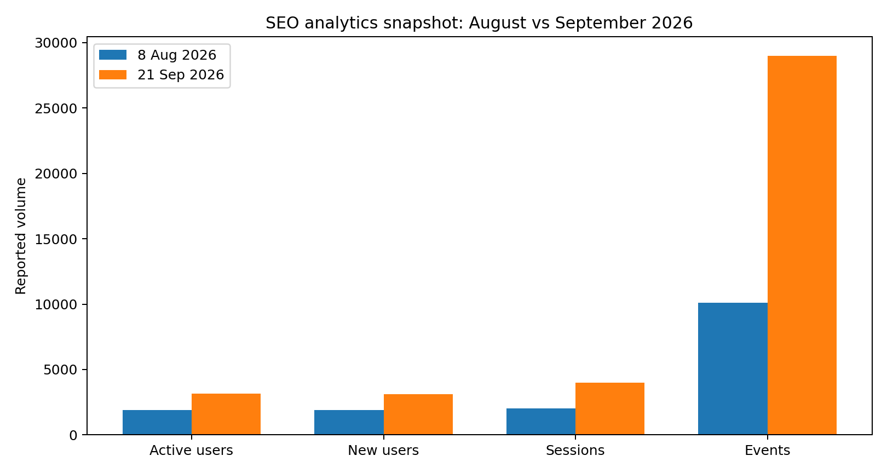
Reported analytics snapshots: 8-Aug-2026 vs 21-Sep-2026. The source screenshots use their own reporting windows; treat this as snapshot-to-snapshot movement, not a single continuous attribution series.
Active users  1,917 -> 3,142  +64% between report snapshots | New users  1,907 -> 3,122  +64% between report snapshots | Sessions  2,024 -> 3,997  +98% between report snapshots
Events  10,097 -> 29,001  +187% between report snapshots | Engagement rate  28.26% -> 20.87%  -7.39 percentage points | Avg. engagement time  12s -> 24s  ~2x longer in the Sept snapshot

Read the engagement shift carefully
The September snapshot shows a lower overall engagement rate than August, but average engagement time roughly doubled. Organic Search also recorded 78.1% engagement in the September channel table, materially higher than Direct at 15.36%.

04 / KEYWORD FOOTPRINT
The query set broadened beyond the brand
Keyword tracking evolved from core branded / stream phrases into a wider semantic cluster around media network, streaming TV, monetization and the independent-artist proposition.
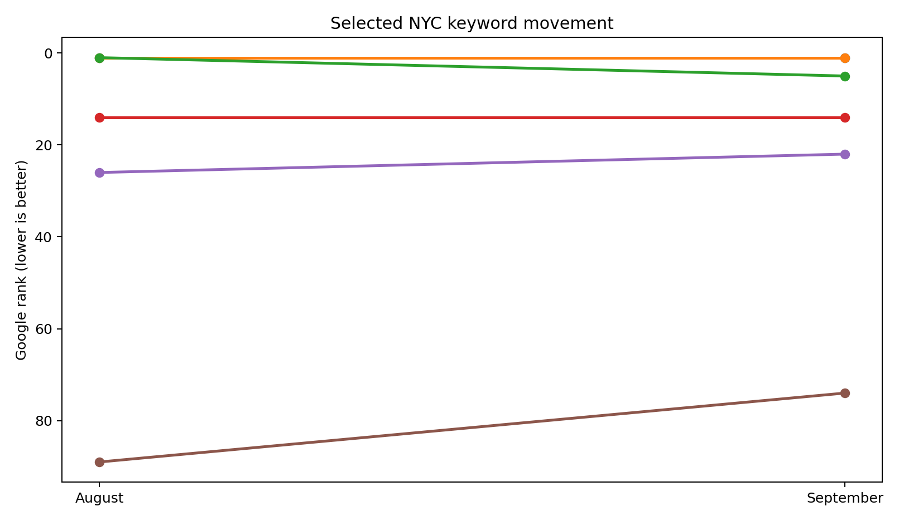
Selected stable or closely related NYC terms. Lower rank number indicates a stronger position. New terms in September are not treated as direct movement from an August term.
Metric | 8-Aug-2026 | 21-Sep-2026 | Interpretation
Tracked NYC keywords | 11 | 10 | The tracked set changed slightly.
Page-1 positions | 4 / 11 | 5 / 10 | Page-1 coverage remained strong while the query mix evolved.
Subamerica Creator Portal | #1 | #1 | Core brand/product discovery held the top position.
Subamerica Network | #1 | #1 | Branded entity query remained #1.
Independent artist platform NYC | #14 | #14 | Stable page-2 presence.
Music monetization platform NYC | #26 | #22 | Movement toward page 3.
Underground artists community NYC | #89 | #74 | Improved visibility, but still outside page 1.

05 / AEO PERFORMANCE
From crawl readiness to answer readiness
The AEO diagnostics show a meaningful change in the audited footprint and in the AI-facing health metrics.
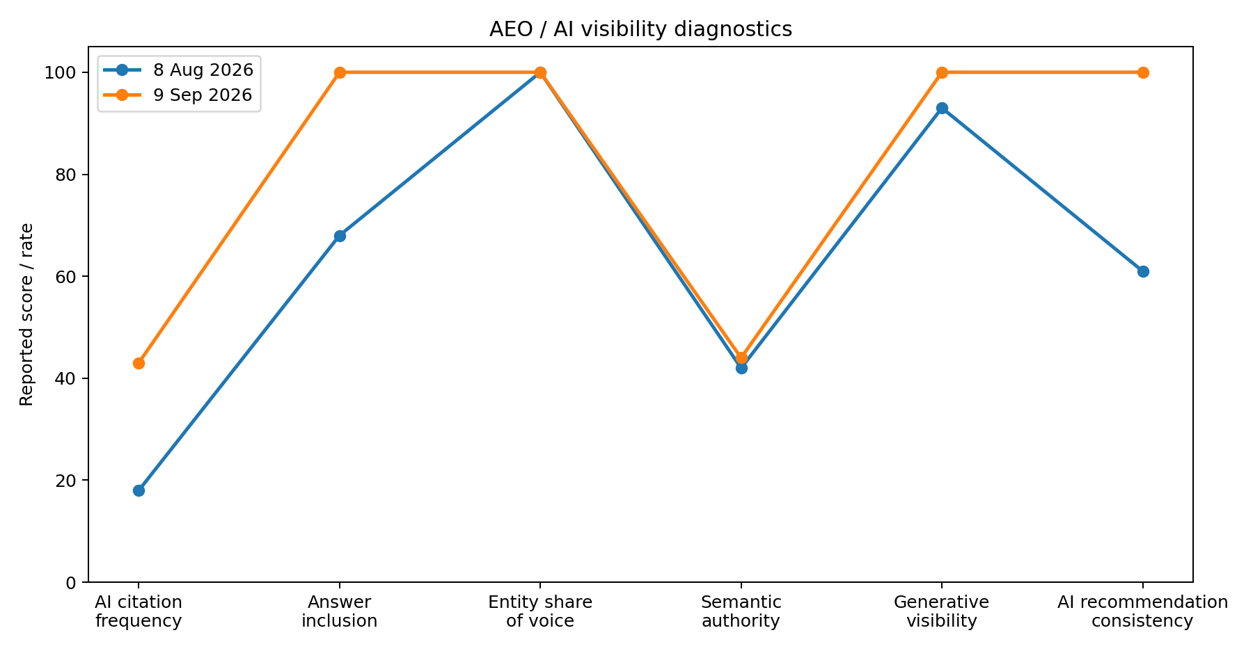
AEO / AI visibility diagnostic comparison using the August and September report values.
AEO diagnostic | Aug 8 | Sep 9 | What changed
Pages crawled | 46 | 66 | Larger audited footprint
Pages indexable | 46 | 66 | All crawled pages reported indexable
Critical issues | 11 | 4 | Fewer critical issues in the latest audit
AI citation frequency | 18 | 43 | Higher reported citation activity
Answer inclusion | 68 | 100 | Full inclusion rate in latest audit
Generative search visibility | 93 | 100 | Full reported generative visibility
AI recommendation consistency | 61 | 100 | Full consistency in latest audit
Semantic authority | 42 | 44 | Only modest movement; remains a core opportunity

The important caveat
These are diagnostic indicators defined by the supplied AEO reports, not industry-standard rankings. The strongest evidence is the direction of change inside the same audit framework: fewer critical issues and higher answer / generative visibility signals.

06 / GEO PERFORMANCE
Being present in the answer, not only the index
GEO monitoring tested Subamerica across Perplexity, Gemini, ChatGPT and Claude using query sets designed around creator, streaming and independent-media intent.
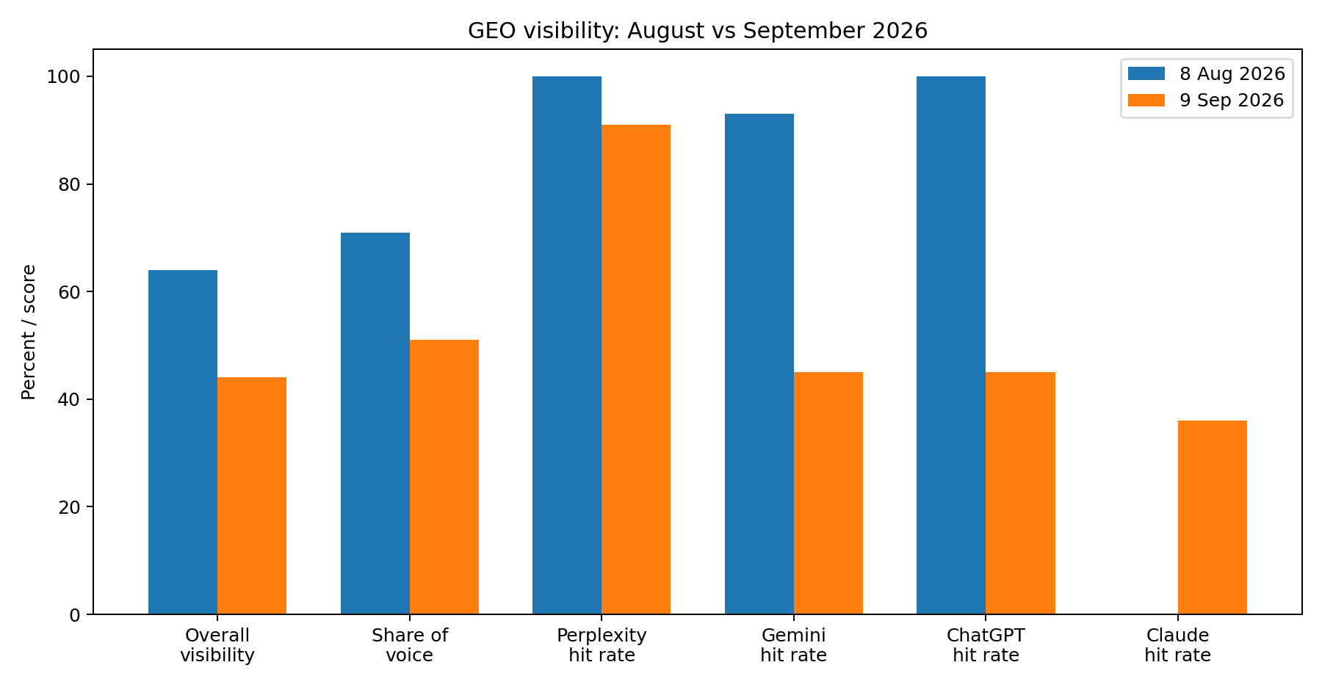
GEO report comparison. Query counts changed between scans, so overall score and share-of-voice should be read as diagnostic snapshots rather than a simple month-over-month growth line.
August scan  64  Overall visibility score.  71% share of voice across 348 model responses from 87 tracked queries.  Hit rates: Perplexity 100%, Gemini 93%, ChatGPT 100%, Claude 0%. | September scan  44  Overall visibility score.  51% share of voice across 169 model responses from 42 tracked queries.  Hit rates: Perplexity 91%, Gemini 45%, ChatGPT 45%, Claude 36%.

What changed in the model mix
September shows less concentrated visibility: Claude moved from 0% to 36% hit rate, while Gemini and ChatGPT fell from their August test levels. That makes the September picture broader across models, but also more variable by model and query set.

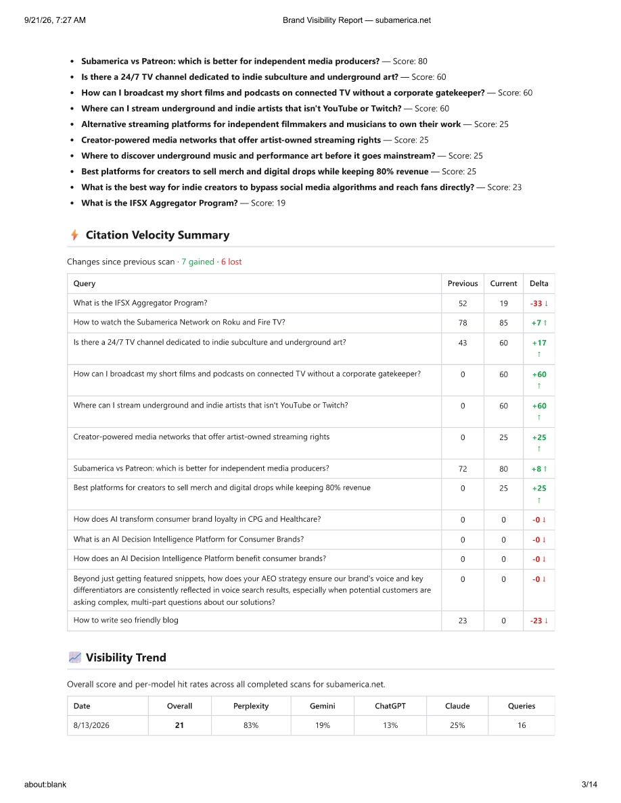
September GEO evidence: top cited queries and citation-velocity summary.

07 / DELIVERY SYSTEM
A practical three-layer visibility engine
The monthly reports show SEO, AEO and GEO reinforcing the same content and entity architecture rather than operating as separate tactics.
Layer | Execution documented in reports | Why it matters
SEO | NYC keyword tracking; off-page distribution; branded and semantic query expansion | Creates conventional search entry points and supports discoverability for creator / streaming intent.
AEO | Schema; FAQ and answer content; semantic HTML; internal linking; page depth; entity and organization signals | Makes the site easier for search engines and AI systems to parse, summarize and connect.
GEO | Multi-model query testing; heat maps; citation velocity; share of voice; competitor benchmarks | Measures whether Subamerica appears in AI answers and what sources / queries drive that visibility.
Entity / authority | Brand mentions, creator / media profiles, Wikidata and structured “sameAs” direction | Builds a clearer machine-readable identity beyond the primary domain.

Core content / technical opportunities surfaced by the reports
- Expand structured answer content and FAQ schema on high-value pages.
- Strengthen semantic HTML and heading hierarchy across creator, watch, channel, network and service pages.
- Increase internal linking depth so related creator / streaming concepts are connected more explicitly.
- Improve entity consistency and authoritative external references so AI systems can resolve Subamerica as a distinct organization.
- Develop comparison and definition-first pages around monetization, platform access, creator ownership and streaming distribution.
A single ontology across all three layers
The most durable part of the program is consistency: “Subamerica,” “creator portal,” “indie underground,” “streaming,” “connected TV,” “artist-owned,” and “monetization” recur across keyword tracking, AEO questions and GEO model prompts.

08 / EVIDENCE
Source-report evidence gallery
Selected first-page and diagnostic snapshots are included so the case study can be audited and repurposed for a web case-study page.
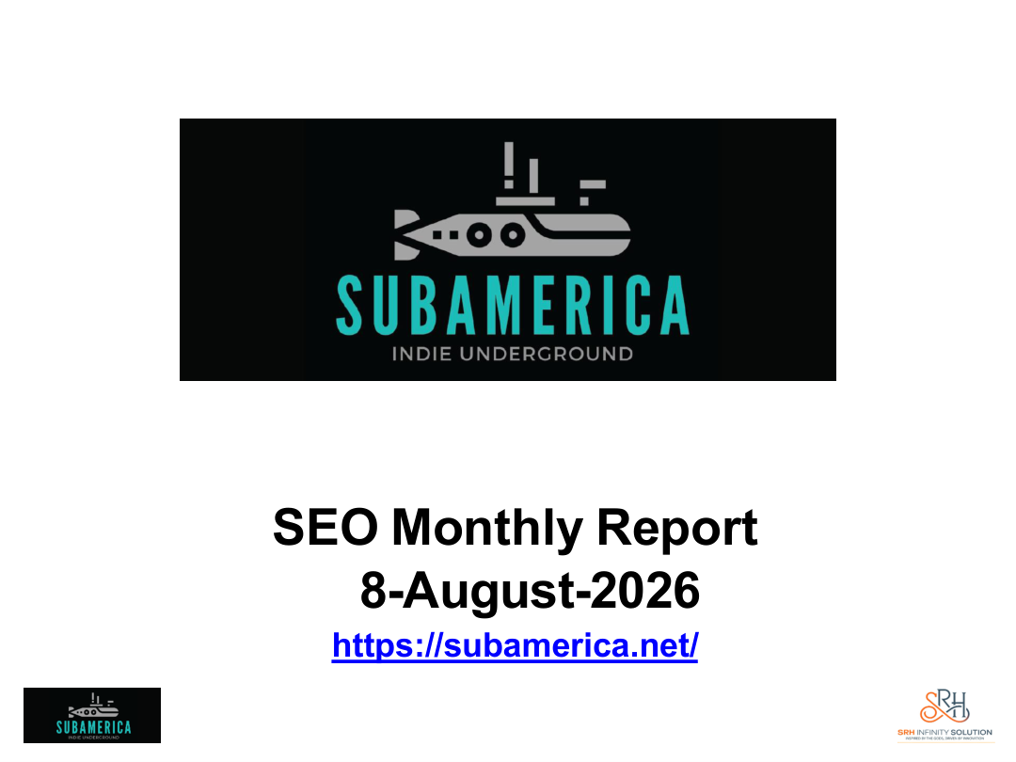  SEO report cover - 8 Aug 2026 | 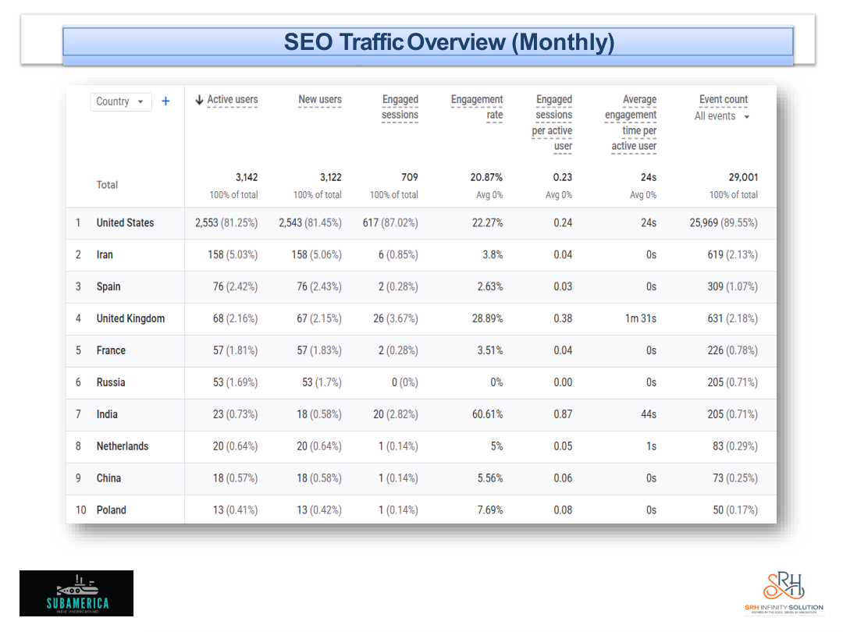  SEO audience / channel snapshot - 21 Sep 2026
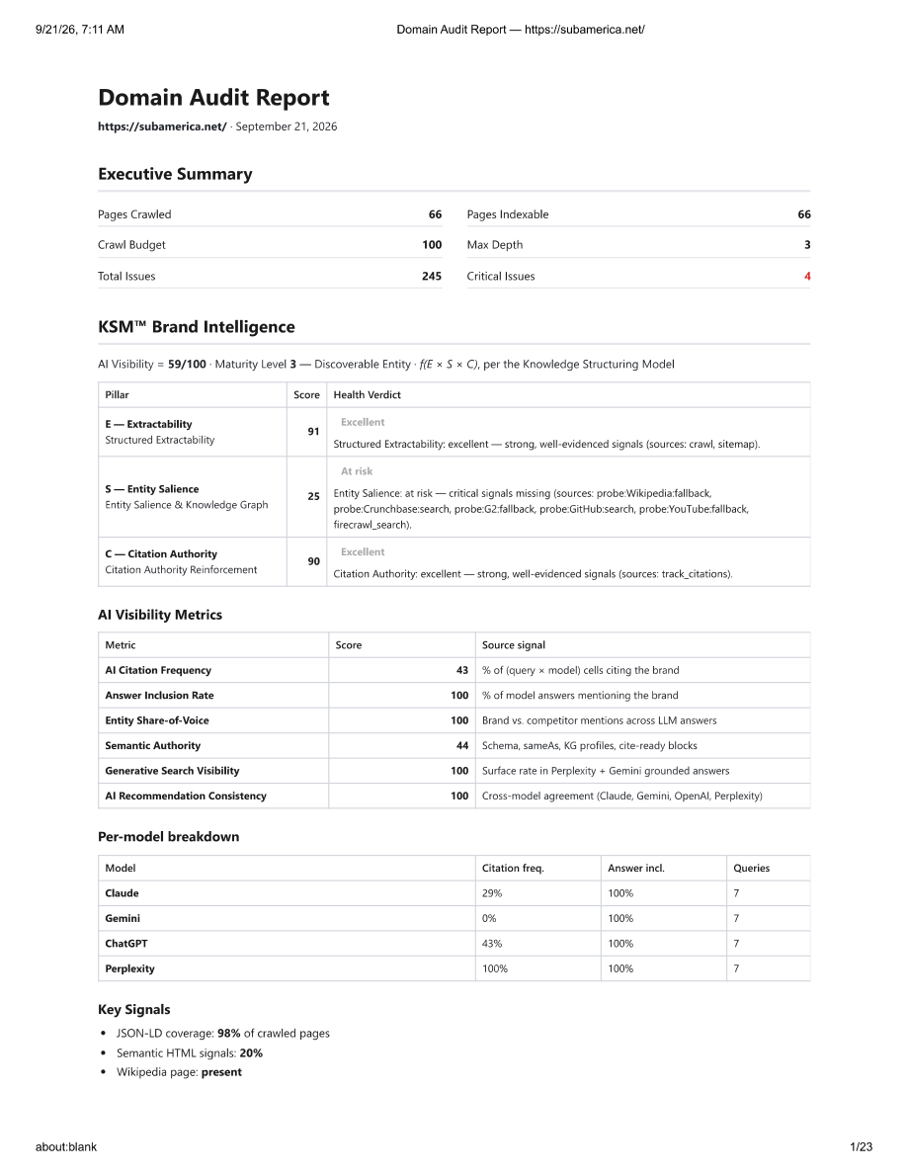  AEO domain audit - 9 Sep 2026 | 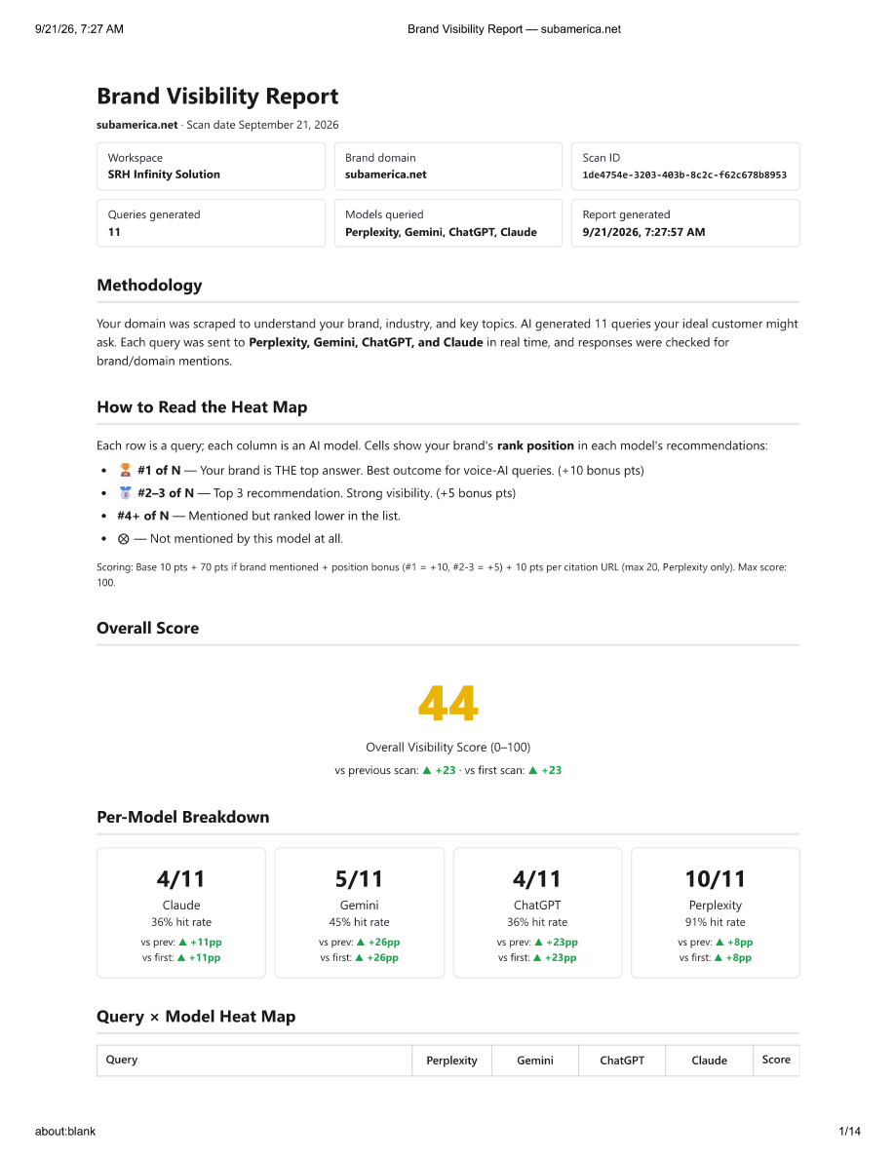  GEO brand visibility report - 9 Sep 2026
Evidence source: client-provided monthly SEO, AEO and GEO reports. Screenshots are supporting exhibits; headline metrics are summarized in the preceding pages.

09 / IMPLICATIONS
What the work demonstrates
The case is best understood as a transition from “being findable” to “being understandable and citable” across multiple discovery systems.
Demonstrated  Branded discovery: Subamerica Creator Portal and Subamerica Network were #1 in both August and September SEO snapshots.  Semantic discovery: page-1 coverage expanded to include Indie Underground Media Network and Indie Underground Streaming TV at #1 in September.  Search depth: September organic search reported 78.1% engagement, with 32 seconds average engagement time in the channel table.  AI readiness: latest AEO audit reported 100 answer inclusion, 100 generative visibility and 100 recommendation consistency. | Still developing  GEO visibility remained uneven by model; Claude improved into measurable territory, while Gemini and ChatGPT were lower in the September scan.  The latest AEO diagnostic still shows limited semantic authority and entity salience as important next-stage work.  Non-branded discovery for artist community and monetization terms remained weaker than the core branded footprint.  The supplied reports do not establish a direct lead or revenue attribution, so none is claimed here.

Next-stage priorities
- Scale creator-first and streaming-first answer pages around the highest-value GEO question families.
- Build stronger “why / how / what” definitions for Subamerica’s unique platform proposition.
- Continue entity reinforcement through authoritative organization profiles and consistent cross-platform references.
- Use GEO query testing to turn AI-citation gaps into concrete content briefs and FAQ / schema updates.
- Keep the strongest branded query positions stable while expanding category-level discovery beyond the brand name.
Publishing angle
For a Muse website case-study page, lead with the 3,142 active-user / 3,997-session September snapshot, the #1 branded keyword positions, and the 100/100/100 AEO visibility signals - then explain the GEO nuance and diagnostic caveats below.

10 / METHODOLOGY
How the results were interpreted
This case study is source-bound. It uses the six supplied reports plus limited current-site context used only to describe the client proposition.
Source set
- SEO: 8-Aug-2026 and 21-Sep-2026.
- AEO: 8-Aug-2026 and 9-Sep-2026.
- GEO: 8-Aug-2026 and 9-Sep-2026.
- Total: six supplied reports.
Interpretation rules
- Analytics changes are described as snapshot-to-snapshot movement because the report screenshots define their own windows and attribution settings.
- Keyword page-1 counts are taken directly from the listed NYC tables in each SEO report; because the tracked set changed, counts are not treated as a like-for-like cohort.
- GEO overall score and share of voice are treated as test-set diagnostics. August and September used different query volumes, so a lower score in September is not described as a simple performance decline.
- AEO diagnostic scores are kept in the source report’s terminology. They are not presented as industry-standard rankings.
- No claim of leads, revenue or conversion lift is made because the supplied material does not prove those outcomes.
Current website context
The current Subamerica site describes the network as an indie underground streaming destination, with 24/7 broadcast positioning and access through Roku, Google TV, Fire TV and Apple TV. That context helps explain why the tracked SEO/AEO/GEO query families center on streaming, creator access, independent media and monetization.
Source | Use in this case study
Subamerica website - subamerica.net | Client proposition / current site context
Muse Platforms - museplatforms.com | Service-positioning context for SEO / AEO / generative AI search
Six client-provided reports | All performance metrics, keyword positions, diagnostic scores and evidence screenshots

Prepared for website case-study publication by Muse Platforms. Data represented: August-September 2026 report snapshots.

