
MUSE PLATFORMS
Al-Ajaleen
SEO + AEO + GEO Case Study
Building search visibility, AI discoverability and brand presence for a legal & intellectual property firm
 | 
Reporting evidence supplied: June–September 2026 | 9 SEO / AEO / GEO reports

01 / EXECUTIVE SNAPSHOT
From traditional search to AI discovery
A documented view of the work delivered across SEO, Answer Engine Optimization and Generative Engine Optimization for ajaleen.com.
Search clicks  115  July AEO report: +89% vs prior period | Search impressions  9.76K  July AEO report: +30% vs prior period | Indexed pages  148  July AEO report snapshot
Answer inclusion  96  September AEO audit | Generative visibility  93  September AEO audit | AI recommendation consistency  91  September AEO audit

Case-study thesis
The supplied reports show a layered visibility program: SEO built market-level keyword coverage; AEO improved answerability, structure and AI extraction; GEO tested whether Ajaleen was actually present, cited and recognized across multiple AI answer systems.

Traditional Search  17 / 30  Among the 30 market-specific top-10 keyword rows shown for Saudi Arabia, Oman and the UAE in the September SEO report, 17 rank on page 1.  The core branded/legal query “al ajaleen law firm & intellectual property” is #1 in all three markets. | AI Search  39%  The September GEO report records Ajaleen with 39% share of voice across 100 model responses.  The latest AEO audit also reports 96 answer inclusion, 93 generative search visibility and 89 citation authority.

Client focus: intellectual property, trademark, patent and corporate/commercial legal services across Saudi Arabia and the GCC.

02 / CONTEXT
The visibility problem we set out to solve
Ajaleen needed to be discoverable not only for conventional legal queries, but for the increasingly conversational, question-led journeys happening inside AI-powered search.
Challenge  Legal and IP services are high-intent, jurisdiction-specific and question-heavy. The program therefore had to make service expertise easy to find, understand and reference across search and AI systems.  The June audit also surfaced technical and structural gaps around answerability, schema coverage, headings, meta completeness and entity signals. | Objectives  1) Grow qualified organic visibility across Saudi Arabia, Oman and the UAE.  2) Create answer-ready content for FAQs, service queries and long-tail legal questions.  3) Improve structured data, internal linking and entity clarity.  4) Build cross-platform brand mentions that support AI recognition and citation.

What the service mix covered
SEO  Keyword + content + technical  Market-specific rankings, site structure and authority building | AEO  Answer-first content + schema  FAQs, semantic structure, internal links and extraction readiness | GEO  AI visibility + brand signals  Model monitoring, citations, share of voice and question coverage

Why this matters
Muse positions AEO and generative AI search optimization as an emerging practice for adapting discovery to AI-driven search. The Al-Ajaleen work reflects that same shift: the optimization target is not just a blue-link ranking, but whether an AI system can understand, cite and recommend the brand.

Source note: scope and workstreams are synthesized from the June and July AEO/GEO reports and the July, August and September SEO reports supplied for this case study.

03 / SEO PERFORMANCE
Search visibility became a broader market footprint
The SEO reports show established positions across Saudi Arabia, Oman and the UAE, with a notable acceleration in the UAE keyword cluster between the August and September snapshots.
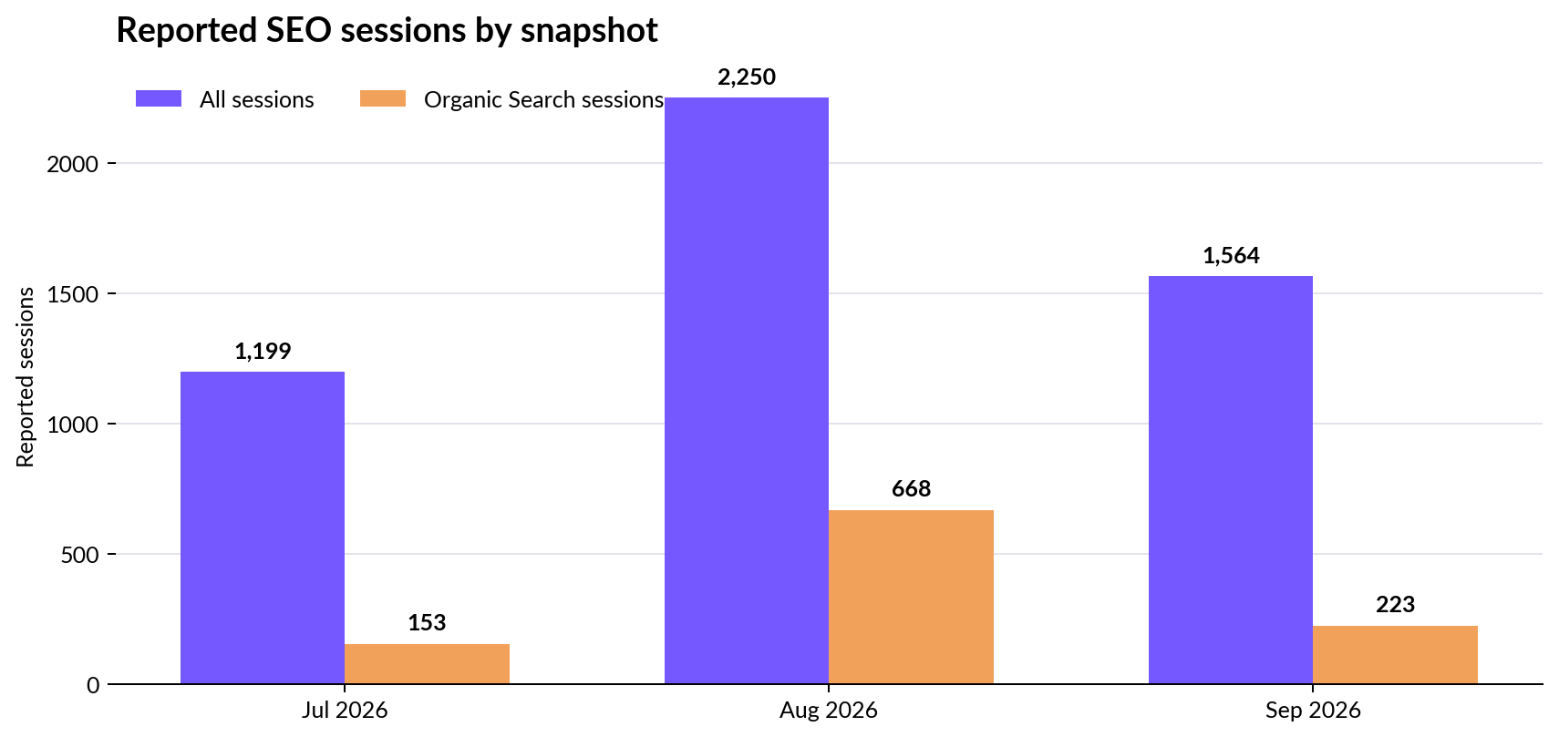
Source: July, August and September 2026 SEO report engagement snapshots. Values are reported-session snapshots, not a single continuous analytics series.
Sep organic search sessions  223  56.5% engagement rate; 32s average engagement time | Sep total sessions  1,564  19.82% overall engagement rate | Sep AI Assistant sessions  7  71.43% engagement rate; 34s average engagement time

Interpretation
Organic Search is a smaller channel than Direct in the September GA snapshot, but it is materially more engaged: 56.5% engagement rate for Organic Search versus 13.12% for Direct. The September report also shows AI Assistant traffic at 71.43% engagement, although the volume is still small.

04 / KEYWORD FOOTPRINT
Winning the right questions in the right markets
The tracked keyword set is localized by market and closely tied to Ajaleen’s legal/IP services.
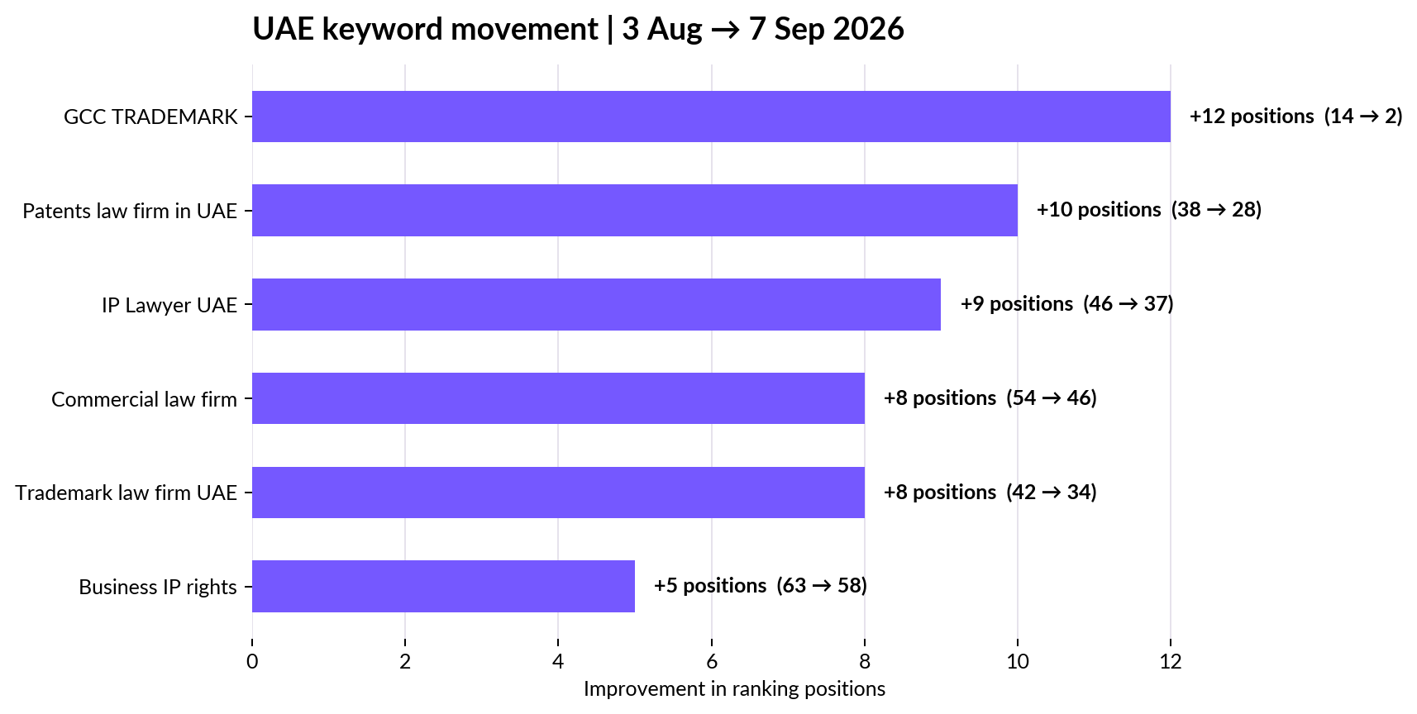
Source: August 3 and September 7, 2026 SEO reports. Positive values show positions gained (lower rank number).
Market | Page-1 positions | Examples from September report
Saudi Arabia | 7 / 10 | Core branded query at #1; IP law firm #4; patents #6; trademark #7
Oman | 6 / 10 | Core branded query at #1; law firm & IP #4; IP law firm #5; SAIP #6
UAE | 4 / 10 | Core branded query at #1; GCC TRADEMARK #2; law firm & IP #5; SAIP #8
All three | 17 / 30 | Page-1 positions among the three 10-keyword market lists shown in the September report

UAE movement
The largest reported gain in the August → September comparison is GCC TRADEMARK, moving from #14 to #2. Other tracked UAE queries improved by 5–10 positions.

05 / AEO PERFORMANCE
Turning legal content into answer-ready assets
AEO work focused on making Ajaleen easier for search engines and AI systems to parse, summarize and cite.
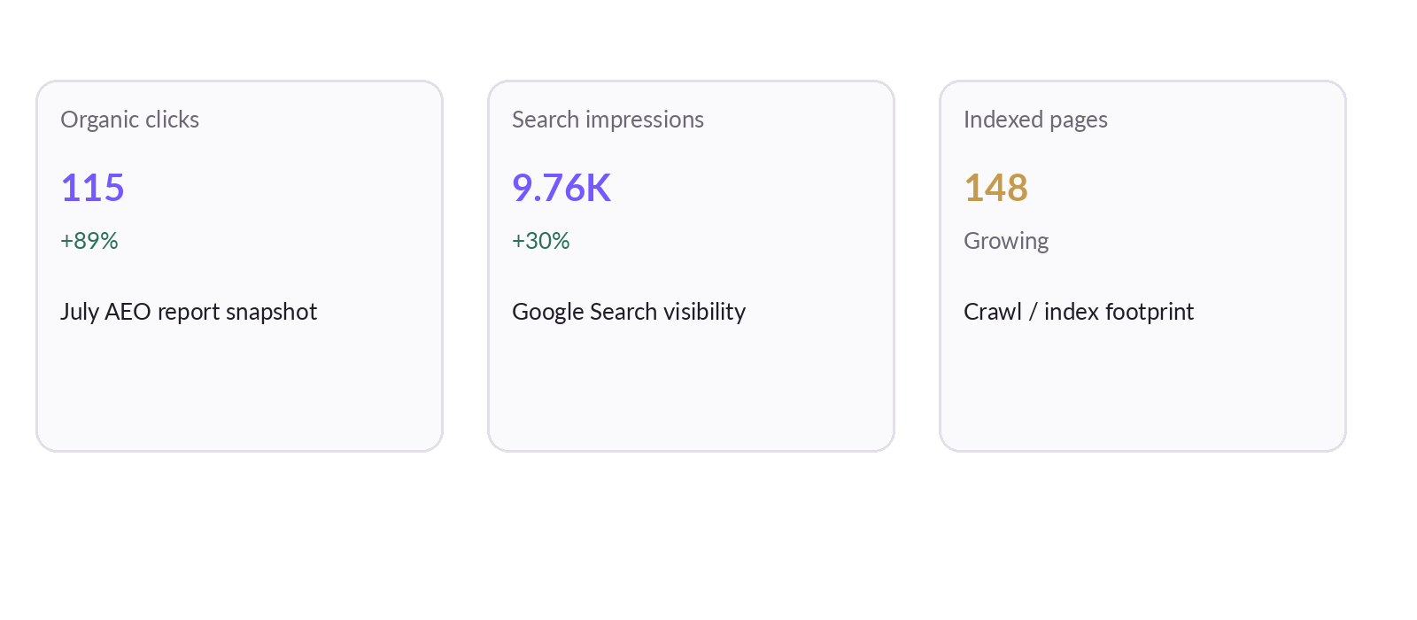
Source: July 7, 2026 AEO report.
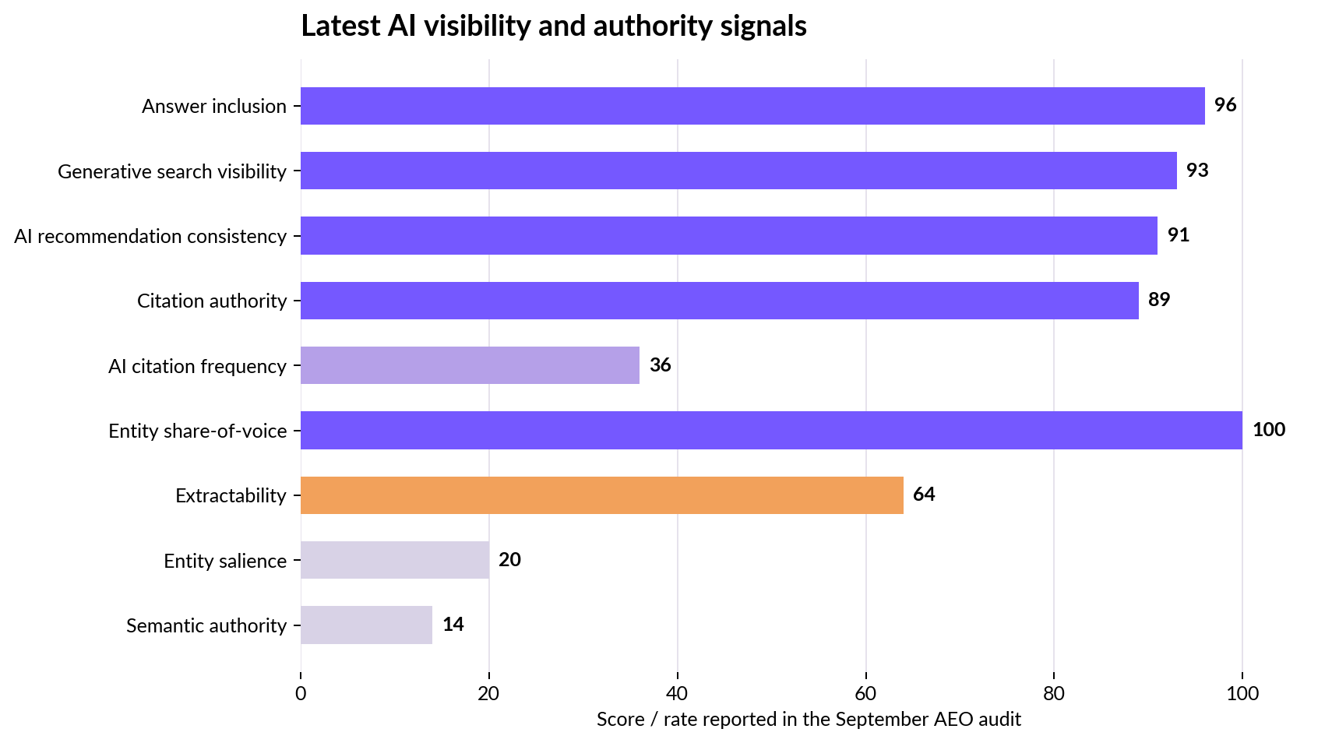
Source: September 7, 2026 AEO Domain Audit. Scores/rates are the report’s own diagnostic measures.
AEO work executed
FAQ optimization, AI-ready legal articles, question-led headings, topical clusters, internal linking and structured data across key pages. The July report also documents brand-entity development across Reddit, Quora, Medium, Pinterest, Blogger and Tumblr.

06 / GEO PERFORMANCE
Moving from “ranking” to “being mentioned”
GEO testing in September evaluated Ajaleen’s visibility across Perplexity, Gemini, ChatGPT and Claude using 25 tracked questions.
September GEO snapshot  34  Overall visibility score reported on the Brand Visibility Report.  Model hit rates: Claude 16%; Gemini 24%; ChatGPT 24%; Perplexity 92%.  39% share of voice across 100 model responses. | What the report surfaced  High-value question themes included GCC trademark protection, commercial-court trademark enforcement, pharmaceutical patent advantages and UAE exhibition trademark protection.  Top cited query scores reached 78 for a trademark-enforcement question; several other queries scored 60+.  A content gap was identified for a temporary-trademark-protection question in the UAE.

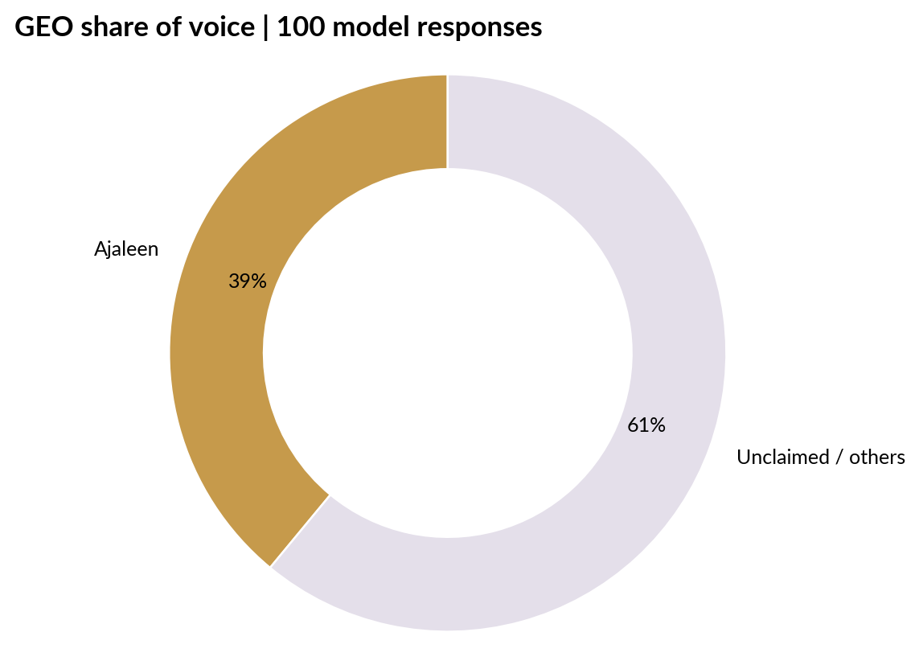
Source: September 7, 2026 GEO Brand Visibility Report.
Why GEO is strategically different
GEO measures the probability that the brand is surfaced and cited inside an answer, not merely listed among conventional search results. For a legal firm, that means authority signals, question coverage and citation-ready source pages become part of discoverability.

07 / TECHNICAL READINESS
The work strengthened the machine-readable foundation
The audit history shows a moving technical baseline, with remediation priorities shifting from basic answerability and crawl quality toward entity clarity, schema depth and semantic authority.
Audit snapshot | Reported finding | What it meant
June 9, 2026 | 42 answerability; 58 visibility; 87 trust readiness; 100 crawl health; 100 topical cohesion; 7 critical issues | Early gaps centered on structured data, answer-style content and visibility/trust signals.
July 7, 2026 | 44 answerability; 57 visibility; 45 trust readiness; 98 crawl health; 100 topical cohesion; 1 critical issue | Critical issue count was substantially lower in the July audit snapshot, while topical cohesion remained high.
Sep 7, 2026 | 48 AI Visibility / Maturity Level 3; 64 extractability; 20 entity salience; 89 citation authority | The latest audit shows strong citation-related signals alongside clear opportunities to improve entity and semantic authority.

Latest September diagnostic signals
Citation authority  89  Excellent in the audit’s own health verdict | Generative visibility  93  Strong surface rate in Perplexity + Gemini grounded answers | Entity share of voice  100  Brand vs competitor mentions in the audit
Entity salience  20  Primary gap flagged by the audit | Semantic authority  14  Next-stage schema / sameAs / knowledge graph opportunity | JSON-LD coverage  10%  Only 10% of crawled pages had JSON-LD coverage in the latest audit

Read this as an optimization roadmap
The latest audit should not be presented as a “finished” state. It is stronger to show that citation and recommendation signals are already measurable while entity and semantic foundations are still being expanded.

08 / DELIVERY SYSTEM
A three-layer visibility program
The reports show the work progressing from content and technical foundations into recurring AI visibility testing and entity reinforcement.
Layer | Execution | Evidence in supplied reports
SEO | Market keyword targeting; content optimization; off-page distribution; internal linking; localized service relevance | September report: 20 tracked Saudi, 20 Oman, 20 UAE keyword rows; 30 localized top-10 rows summarized in the case study.
AEO | FAQ optimization; direct-answer formatting; schema; question-led headings; topical clusters; UX readability | July report documents FAQ and blog optimization plus 8 schema types and entity development across six external platforms.
GEO | 25-question AI model test; model heat map; citation tracking; share of voice; competitor benchmark; content gaps | September GEO report tests 25 queries across Perplexity, Gemini, ChatGPT and Claude and reports 39% share of voice.
Entity / trust | Cross-platform brand mentions; organization attributes; sameAs / knowledge graph expansion; citation-ready sources | September AEO audit reports strong citation authority but lower entity salience and semantic authority, which directly informs the next work cycle.

Content themes that matched commercial intent
- Trademark registration and protection across Saudi Arabia, UAE and the GCC.
- Patent registration, IP protection and legal guidance in Saudi Arabia and the UAE.
- Corporate and commercial legal services, company formation and business setup.
- Conversational “how do I…” questions designed to be answered directly inside AI interfaces.
A key pattern
The SEO keyword themes, AEO question structures and GEO question bank were aligned around the same service ontology: trademarks, patents, intellectual property and business law. That consistency is the bridge between search visibility and AI entity recognition.

09 / EVIDENCE
Source-report evidence gallery
Selected snapshots from the supplied reports. These are included to make the case study auditable and web-publishing ready.
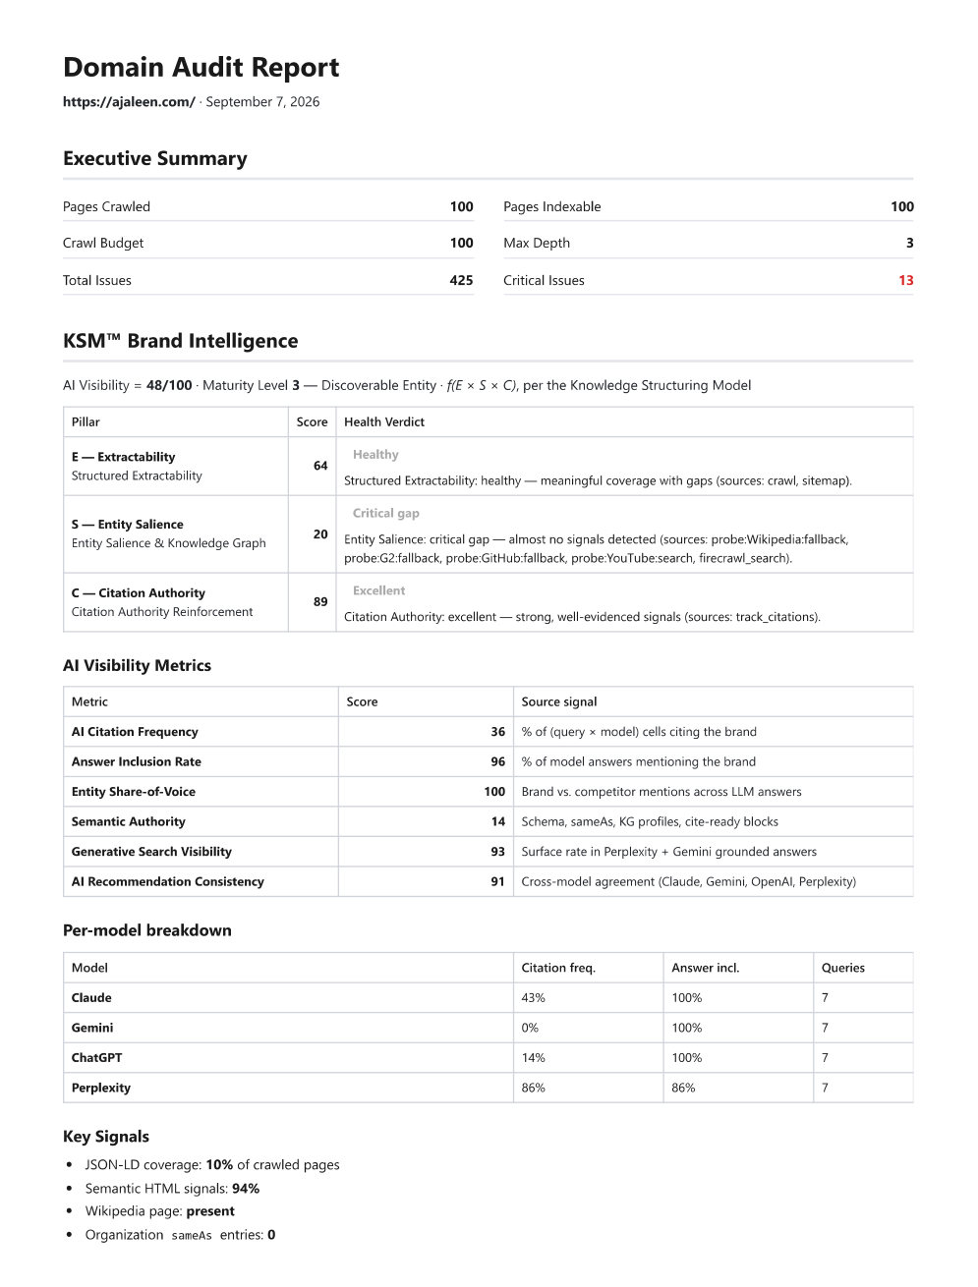  AEO audit — Sept 7, 2026 | 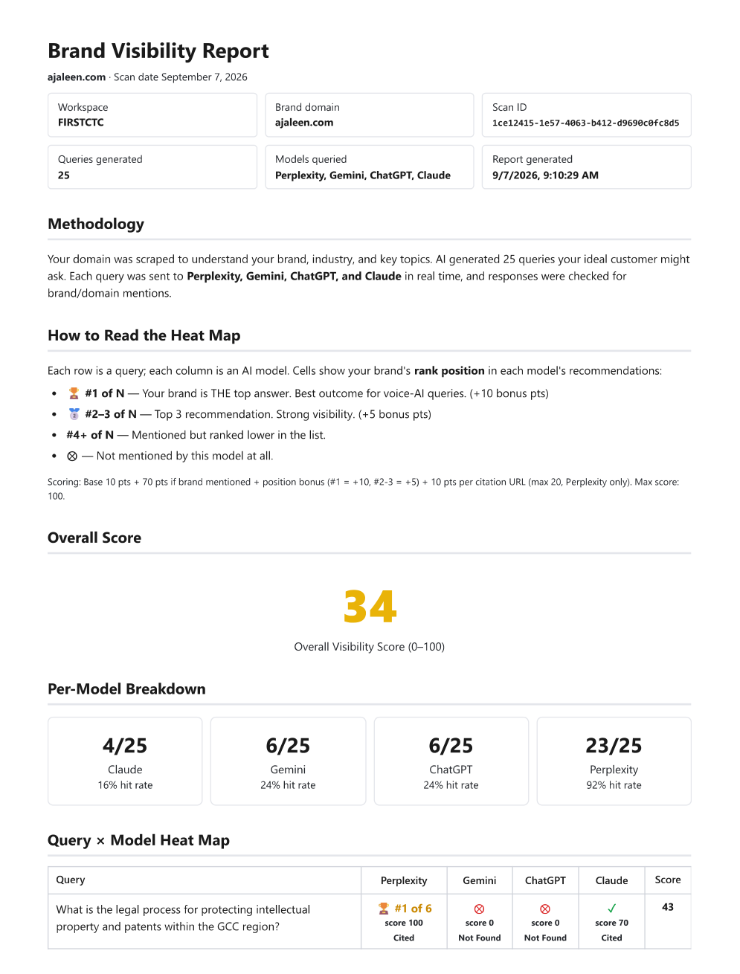  GEO brand visibility — Sept 7, 2026
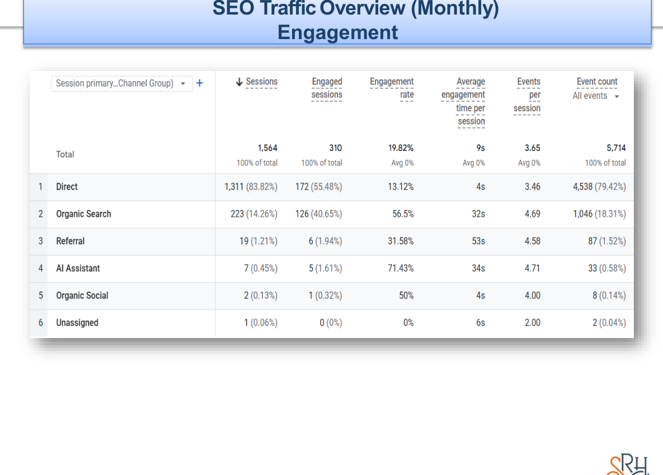  SEO engagement — Sept 7, 2026 | 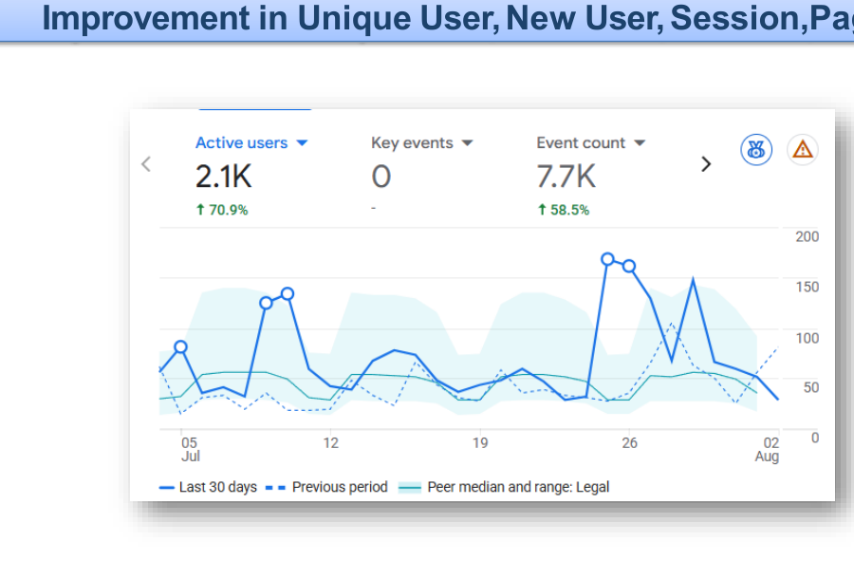  SEO audience snapshot — Aug 3, 2026
Evidence source: client-provided monthly reports for Ajaleen. Screenshots are reproduced only as supporting evidence; headline metrics are summarized separately for readability.

10 / BUSINESS IMPLICATIONS
What this work demonstrates
The case is strongest when the results are framed as a connected visibility system rather than a single SEO metric.
Demonstrated outcomes  Traditional search: the tracked market keyword set includes page-1 coverage in all three target markets.  UAE: the tracked cluster shows meaningful position gains between the August and September snapshots.  AEO: the July report shows 115 organic clicks (+89%) and 9.76K impressions (+30%), while the September audit shows high answer inclusion, generative visibility and citation authority.  GEO: the September report records 39% share of voice across 100 AI responses and strong coverage in Perplexity. | Ongoing opportunity  Increase entity salience and semantic authority through stronger Organization / sameAs signals and broader authoritative profiles.  Expand direct-answer and comparison content around identified GEO content gaps.  Continue strengthening schema coverage and page-level answer structures.  Build more citation-ready legal reference assets that can serve both search and AI answer journeys.

Recommended next-stage focus from the supplied reports
- Expand service pages and FAQ coverage for trademark, patent, corporate and commercial legal queries across UAE + Saudi + GCC.
- Create / refine definition-first and long-tail answer blocks, especially for queries surfaced in the GEO gap analysis.
- Strengthen organization/entity attributes, sameAs relationships and knowledge-graph references.
- Keep tracking AI citation frequency, share of voice, answer inclusion and recommendation consistency by model.
Publishing note
For the website case-study page, keep the strongest headline figures above the fold, then use the methodology and diagnostic caveats below them. This preserves credibility while making the story easy to scan.

11 / METHODOLOGY
How the numbers were interpreted
This case study is intentionally source-bound: every headline result below comes from the client-provided SEO, AEO or GEO reports supplied for the engagement.
Source set
- SEO reports: 7 July 2026, 3 August 2026 and 7 September 2026.
- AEO / AEO + GEO reports: 9 June 2026, 7 July 2026 and 7 September 2026.
- GEO reports: 7 July 2026 and 7 September 2026.
- Total supplied source documents: 9 reports covering June–September 2026.
Interpretation rules
- Where report screenshots use relative-period comparisons (for example, +89% clicks), the wording is retained as a report-reported change and not recalculated from an unseen baseline.
- Keyword movement is calculated only where the same query appears in both the August 3 and September 7 SEO reports.
- The 17 / 30 page-1 figure is a direct count across the 10-keyword Saudi, Oman and UAE tables shown in the September SEO report.
- AEO and GEO diagnostic scores are reported as the source reports define them; they should be treated as program-specific visibility indicators, not industry-standard rankings.
- No lead, revenue or conversion lift is claimed because the supplied reports do not establish a direct causal measurement for those outcomes.
External context used for positioning
The current Muse Platforms site describes Generative AI Search Engine Optimization as an emerging practice for adapting discovery to evolving search behavior, while the Ajaleen site presents the firm as a legal and intellectual property practice serving the GCC. Those descriptions provide contextual framing only; the performance claims in this document come from the supplied reports.
Source | URL
Muse Platforms | https://museplatforms.com/
Ajaleen | https://ajaleen.com/

Prepared as a web-ready case study document for Muse Platforms. Data window represented: June–September 2026.

